**Vortex Mixer**

**user manual**

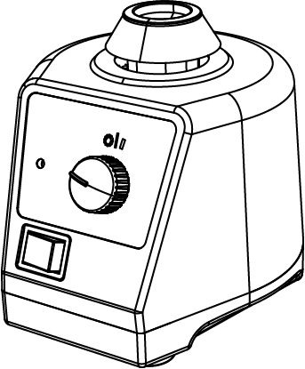

*Please read the User Manual carefully before use, and follow all operating and safety instructions! Technical specifications and outline are subject to change without prior notice.*

12302078



Ver.20220118

CONTENTS

Preface 1

Service 1

Warranty 2

1. Safety Instructions 3

2. Proper use 5

3. Inspection 5

3.1. Receiving Inspection 5

3.2. Listing of Items 5

4. Trial run 6

5. Operation 7

5.1 Continuous operating 7

5.2 Touch operating 8

6. Maintenance and Cleaning 9

7. Associated standards and regulations 10

8. Technical data 11

9. Applications 13

Preface

Welcome to the “Vortex Mixer (Adjustable and Fixed Speed Models) User Manual”. Users should read this manual carefully, follow the instructions and procedures, and beware of all the cautions.

Service

When help needed, you can always contact the service department of manufacturer for technical support in the following ways:

Please provide the customer care representative with the following information：

* Serial Number (on the bottom panel)
* Certification
* Description of problem
* Methods and procedures adopted once to resolve the problems
* Your contact information

Warranty

This instrument is warranted to be free from defects in materials and workmanship under normal use and service, for a period of 24 months from the date of invoice. The warranty is extended only to the original purchaser. It shall not apply to any product or parts which have been damaged on account of improper installation, improper connections, misuse, accident or abnormal conditions of operation.

For claims under the warranty please contact your local dealer. You may also send the instrument direct to our works, enclosing the invoice copy and by giving reasons for the claim.

1. Safety Instructions

|  |  |
| --- | --- |
| P52L3TB10inTB | **Warning!**   * Read the operating instructions carefully before use. * Ensure only trained staff uses the instrument. |
| P52L3TB10inTB | **Protective ground contact！**   * Make sure the socket is grounded before use. |

* Wear the personal safety items to avoid the risk from
* Splashing of liquids.
* Mechanical vibration may lead to glass breakage.
* Trapping parts of the body, hair or pieces of clothing in the moving parts.
* During manual manipulation:
* Keep medium vessels vertical as much as possible.
* Mix the medium in the minimum pressure required.
* Use attachment supplied when mixing a mass of different medium.
* Set up the instrument in a spacious area on a stable, clean, non-slip, dry and fireproof surface. Do not operate the instrument in explosive atmospheres, with hazardous
* Put the speed control knob to the lowest position. Gradually increase the speed (adjustable speed model), reduce the speed if:
* The medium splashes out of the vessel because of too high speed.
* The instrument is not running smoothly or moves on the stage.
* Safe operation is only guaranteed with the accessories described in the “Accessories” chapter.
* Accessories must be securely attached to the instrument and can not come off by themselves.
* Check the instrument and accessories before each use. Do not use damaged components.
* Place a vessel at the center of the mixing head and spread out others uniformly.
* A sharp edged vessel can wear-out the mixing head.
* Always disconnect the plug before fitting accessories.
* The instrument may heat up when in use.
* The operating voltage required on the label and voltage supply network must match.
* Protect the instrument and accessories from bumps and impacts.
* The instrument may only be opened by qualified and trained technician.

2. Proper use

The instrument is designed for mixing liquids in schools, laboratories or factories. This device is not suitable for use in residential areas or other areas that may cause danger to the user or instrument as mentioned in Chapter 1.

3. Inspection

## 3.1. Receiving Inspection

Unpack the equipment carefully and check for any damages which may have arisen during transport. Please contact manufacturer/supplier for technical support.

|  |  |
| --- | --- |
| P52L3TB10inTB | **Note:**  If there is any apparent damage to the system, please do not plug it into the power line. |

## 3.2. Listing of Items

The package includes the following items:

|  |  |
| --- | --- |
| **Items** | **Qty** |
| Main unit | 1 |
| User Manual | 1 |

Table 1

Please retain all packing materials. Additional shipping charges will be assessed if packing is unavailable for the system warranty service.

4. Trial run

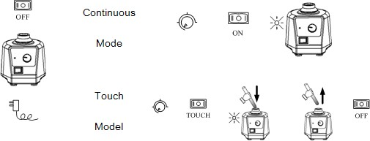

Figure 1

|  |  |
| --- | --- |
| P52L3TB10inTB | **Note:**  Ensure that the two-direction switch must be in the middle (off state) before powering on. |

If these operations above are normal, the instrument is ready to operate following the “operation” chapter. If these operations are not normal, the instrument may be damaged. Please contact manufacturer/supplier for technical support.

5. Operation

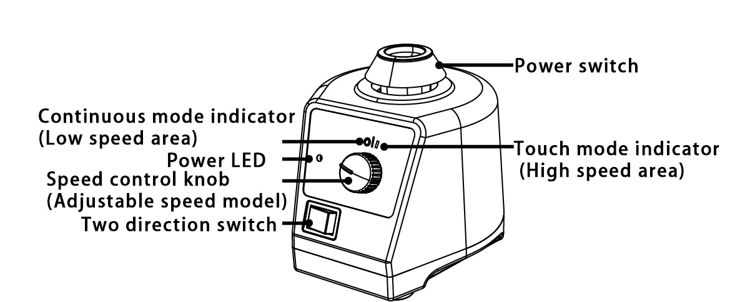

Figure 2

## 5.1 Continuous operating

**ON OFF**



Figure 3

* Place speed control knob at the lowest position. Put the instrument on a stable and safe place and plug in the main power.
* Push the two-direction switch left to ON and power LED is lit.
* Turn the speed control knob to set speed (Adjustable speed model).
* Push the two-direction switch right gently to turn OFF.

## 5.2 Touch operating

**Touch OFF**



Figure 4

* Place the speed control knob at the lowest position. Put the instrument on a stable and safe place and plug in the main power.
* Push the two-direction switch right to the touch mode.
* Turn the speed control knob to set speed (Adjustable speed model).
* If a test tube is pressed into the mixing head vertically, the instrument will begin to work and the power LED will be lit.
* Push the two-direction switch left gently to OFF.

|  |  |
| --- | --- |
| P52L3TB10inTB | **Note:**   * Place vessels as vertical as possible into the center of mixing head for proper mixing. * Adjust the speed control knob slowly in order to have the instrument works smoothly. * Don not run continuous operating mode at high speed area. |

6. Maintenance and Cleaning

* Proper maintenance can keep instrument working and extend its life time.
* Do not spray the cleanser into the instrument when cleaning.
* Unplug the power line when cleaning.
* Only use cleanser as shown below:

|  |  |
| --- | --- |
| Dyes | isopropyl alcohol |
| Construction materials | water containing tenside/ isopropyl alcohol |
| Cosmetics | water containing tenside/ isopropyl alcohol |
| Foodstuffs | water containing tenside |
| Fuels | water containing tenside |

Table 2

* For materials which are not listed, please request information from manufacturer/supplier.
* Before using other method for cleaning or decontamination, the user must ascertain with the manufacturer/supplier whether this method will not harm the instrument.
* Wear the proper protective gloves during cleaning of the instrument.

|  |  |
| --- | --- |
| P52L3TB10inTB | **Note:**   * Electrical instruments may not be placed in the cleansing agent. * The instrument is a sophisticated electronic product, please avoid severe shaking during use and transportation. * The instrument must be cleaned and put it into the initial packaging carton before sending for service, avoid contamination. * Switch OFF the instrument and put it in a dry, clean, stable place at room temperature in long-term disuse |

7. Associated standards and regulations

|  |
| --- |
| Construction in accordance with the following safety standards: |
| EN 61010-1 |
| Construction in accordance with the following EMC standards: |
| EN 61326-1 |
| Associated EU guidelines: |
| EMC-guidelines: 89/336/EWG  Instrument guidelines: 73/023/EWG |

8. Technical data

|  |  |
| --- | --- |
| **Items** | **Specifications** |
| Voltage [VAC] | 220-230 / 110-120 |
| Frequency [Hz] | 50, 60 |
| Power [W] | 60 |
| Shaking movement | orbital |
| Orbital diameter [mm] | 4 |
| Motor type | Shaded-pole motor |
| Motor rating input [W] | 58 |
| Motor rating output [W] | 10 |
| Speed range [rpm] | 0-2500(Adjustable speed model)  2500(Fixed speed model) |
| Speed display | Scale |
| Run type | Continuous/touch operation |
| Dimensions (mm) | 127×130×160 |
| Weight [kg] | 3.5 |
| Permitted ambient temperature[°C] | 5-40 |
| Permitted relative humidity | 80% |
| Protection class acc. To DIN 60529 | IP20 |

**Changing attachment:**

卡通画

Figure 5

9. Applications

|  |  |  |  |  |
| --- | --- | --- | --- | --- |
| **Attachments** | **Fixed speed model**(2500rpm) | | **Adjustable speed model**  (0-2500rpm) | |
|  | Touch mode | Continuous mode | Touch mode (High speed area) | Continuous mode (Low speed area) |
| VTI.1 | Y | Y | Y | Y |
| VTI.2 + VT1.3.1 | Y |  | Y |  |
| VTI.2 + VT1.3.2 | Y |  | Y |  |
| VTI.2 + VT1.3.3 | Y |  | Y |  |
| VTI.2 + VT1.3.4 | Y |  | Y |  |
| VTI.2 + VT1.3.5 | Y |  | Y |  |
| VTI.3 + VT1.3.6 | Y |  | Y |  |
| VTI.3 + VT1.3.1 |  |  |  | Y |
| VTI.3 + VT1.3.2 |  |  |  | Y |
| VTI.3 + VT1.3.3 |  |  |  | Y |
| VTI.3 + VT1.3.4 |  |  |  | Y |
| VTI.3 + VT1.3.5 |  |  |  | Y |

**CONTACT US**



**DLAB Scientific Co., Ltd**

Yu An Road 31, Beijing Airport Economic core zone,

Shun yi District, Beijing, China 101318

Tel: 86-10- 85653451/52/53

Fax: 86-10-85653383

E- mail: [info@dlabsci.com](mailto:info@dlabsci.com)

web: www.dlabsci.com