
DM0412P Low speed Centrifuge
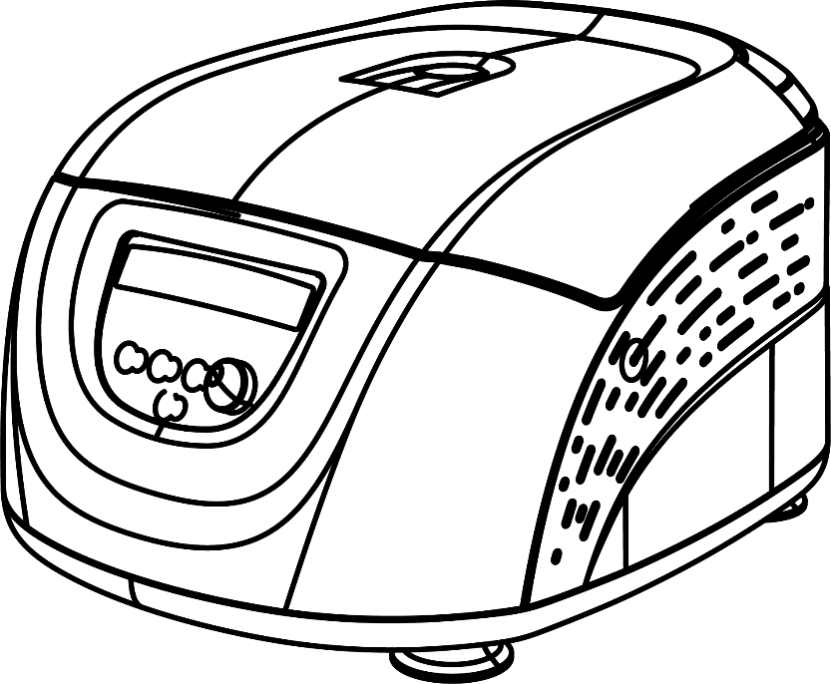



12301628
Ver.20221122
Before using centrifuge, please carefully read this user manual for efficient operation and safety.

Contents
Safety Reminder 1
1. Intended use 5
2. Specifications 5
3. Declaration of Conformity 6
4. Required Operational Conditions 8
4.1 Basic operational conditions 8
4.2 Transport and storage conditions 8
5. Installation 9
5.1 Location 9
5.2 Connection of the power cord and grounding 10
6. Structure 10
7. Operation panel 11
8. Rotor Preparation 13
8.1 Prepare the samples 13
8.2 Inject the samples into tubes 13
8.3 Keep the tubes balanced 14
8.4 Inspect the rotor 14
8.5 Symmetrically load centrifuge tubes into rotor 14
9. Operation 15
9.1 Normal operation 15
9.2 RCF operation 错误!未定义书签。
9.3 Pulse operation 错误!未定义书签。
10. Maintenance 21
10.1 Cleaning 21
10.2 Rotor Installation 23
11. Troubleshooting 25
11.1 Possible problems and solutions 25
11.2 How to open the door 26
12. Instructions for the rotor and tubes 27
12.1 Rotor instructions 28
12.2 Tubes 30
13. Calculate RCF 33
14. Returning and Disposal 33
14.1 Returning Devices 33
14.2 Disposal 33
15．Warranty 34
15.1 Warranty of centrifuge 34
15.2 Warranty of the rotor 34
After-sales service 35

Safety Reminder

Common safety precautions
Carefully read the following safety precautions for a thorough understanding.
- Follow the instructions and procedures described in this manual to operate this centrifuge safely.
- Carefully read all safety messages in this manual and the safety instructions on the instrument.
- Safety messages are labeled as indicated below. They are in combination with signal words of “WARNING” and “CAUTION” with the safety alert symbol to call your attention to items or operations that could be dangerous to you or other persons using this instrument. The definitions of signal words are as follows:

 WARNING：Personal Danger
Warning notes indicate any condition or practice, which if not strictly observed, could result in personal injury or possible death.

CAUTION：Possible damage to instrument
Caution notes indicate any condition or practice, which if not strictly observed or remedied, could result in damage or destruction of the instrument.

NOTE：Notes indicate an area or subject of special merit, emphasizing either the product’s capability or common errors in operation or maintenance.

- Do not operate this centrifuge in any manner not described in this User manual. When in doubt or have any troubles with this centrifuge, ASK FOR HELP.
- The precautions described in this User manual are carefully developed in an attempt to cover all the possible risks. However, it is also important that you are alert for unexpected incidents. Be carefully operating this centrifuge.

WARNING：
- This centrifuge is not explosion-proof. Never use explosive or flammable samples.
- Do not install the centrifuge in or near places where inflammable gases are generated or chemicals are stored.
- Do not place dangerous material within 30cm around the centrifuge.
- Make sure to prepare necessary safety measures before using samples that are toxic, radioactive or contaminated with pathogenic micro-organisms at your own responsibility.
- If the instrument, rotor and/or accessories that has been contaminated by solutions with toxic, radioactive or pathogenic materials, clean it according to the decontamination procedure that you are specified.
- If you require services at site, please sterilize and decontaminate it in advance, and then notice the service center involved in the details of the particular materials.
- Do not handle the power cord or turn on or off the POWER switch with wet hands to void electrical shocks.
- For safety purposes, do not enter within 30cm around this centrifuge while it is in operation.
- While the rotor is rotating, never forcedly release the door lock.
- Unauthorized repairs, disassembly, and other services to the centrifuge except by our service center are strictly prohibited.

CAUTION
- This centrifuge must be located on one firm and level table.
- Make sure the centrifuge is horizontal before running.
- Make sure the angle between the door and cover is greater than 70 degrees when open the door.
- Be careful not put your fingers or hands between the door and cover when the door off.
- Do not move or relocate this centrifuge while it is running.
- If fluid spills in the rotor chamber, please promptly clean and dry with a dry cloth to avoid sample contamination.
- Ensure to remove any objects and fragments of the tubes dropped inside the rotor chamber before running this centrifuge.
- Cautions on rotors
(1) Always check for corrosion and damages on the rotor surface before using it. Do not use the rotor if an abnormality is found.
(2) Do not set the centrifuge speed beyond the allowable minimum speed of the rotor kits (rotor or adapters). Make sure to run it below the allowable minimum speed.
(3) Do not exceed the allowable imbalance.
(4) Use the rotor and tubes within their actual capacities.
(5) If the rotor is attached with a lid, ensure it is tightened before operation.
- If any abnormal condition occurs during operation, please stop it immediately and contact our service center. Notify the service center is a warning code if displayed.
- Vibrations are likely to damage the centrifuge, contact our service center if abnormality observed.

1. Intended use
This device is a medical product (laboratory centrifuge) within the context of the IVD Directive 98/79/EC. The centrifuge is used for the centrifugal separation of human blood or urine samples in the rotor in accordance with EN ISO 12772. Operator should be trained before using the centrifuge. Detailed operation, please refer to the User Manual below.

2. Specifications
Maximum speed | 4500rpm(300-4500rpm), increment: 10rpm
Maximum RCF | 2490×g, increment: 10×g
Maximum capacity | 10ml×12, 15ml×8
Timer | 30seconds -99minutes-HOLD, continuous operation
Noise | ≤56dB(A)
Driving Motor | Brushless DC motor
Safety devices | Door interlock, Over-speed detector, Error code runtime display
Power requirements | Single-phase, 110V-240V, 50Hz/60Hz, 3A.
Ambient condition  -Set-up site  -Altitude  -Ambient temperature  -Humidity  -Excess-voltage category  -Pollution degree | Indoor only  Up to 2000 m above sea level  2°C ～ 40°C  80%  II  2
Device protection class | I
EMC  -Emitted interference,  Interference immunity | EN/IEC 61326-1  Class A | FCC Class A
Dimensions（mm） | （L）301×（W）354×（H）217
Weight | 6kg
Additional features | Speed/RCF switch, Pulse operation, LCD display of runtime status, buzzer notification & alert

3. Declaration of Conformity
Construction in accordance with the following safety standards:
EN 61010-1
EN 61010-2-020
EN 61010-2-101
Construction in accordance with the following EMC standards:
EN 61326-1/ FCC Part 15 Subpart B/ IECS 001
EN 61326-2-6:2006
Associated EU guidelines:
EMCderective:2014/30/EU
LVD derective: 2014/35/EU
IVD derective: 98/79/EC
This ISM device complies with Canadian ICES-001.
Cet appareil ISM est conforme à la norme NMB-001 du Canada.

Changes or modifications not expressly approved by the party responsible for compliance could void the user's authority to operate the equipment.
NOTE: This equipment has been tested and found to comply with the limits for a Class A digital device, pursuant to Part 15 of the FCC Rules. These limits are designed to provide reasonable protection against harmful interference when the equipment is operated in a commercial environment. This equipment generates, uses, and can radiate radio frequency energy and, if not installed and used in accordance with the instruction manual, may cause harmful interference to radio communications. Operation of this equipment in a residential area is likely to cause harmful interference in which case the user will be required to correct the interference at his own expense.

4. Required Operational Conditions

4.1 Basic operational conditions
（1）Power: 110V-240V, 50Hz/60Hz, 3A.
（2）Ambient temperature: 2℃~40℃.
（3）Relative humidity: ≤80%.
（4）No vibration and airflow around.
（5）No electric dust, explosive and corrosive gases around.

4.2 Transport and storage conditions
（1）Storage temperature: -40℃~55℃.
（2）Relative humidity: ≤93%.

5. Installation
This section describes the instructions that you should abide when install the centrifuge to ensure your safety and the optimum performance. Before moving the centrifuge, the rotor must be removed.
WARNING
- Improper power supply may damage centrifuge.
- Make sure the power source conforms to the required power supply before connecting.

5.1 Location
（1）Place this centrifuge on a firm、flat and level surface, ensure the four feet of this centrifuge stand on the counter firmly. Avoid installing on a slippery surface or surface prone to vibration.
（2）Ideal ambient temperature is 20℃±5℃, avoid placing the centrifuge in direct sunlight if temperature exceeds 30℃.
（3）Keep clear of the centrifuge at least 10cm on both sides and at least 30cm behind it to guarantee the cooling efficiency.
（4）Keep away from heat or water to avoid sample temperature issues or centrifuge failures.

5.2 Connection of the power cord and grounding
WARNING
- To avoid electrical shocks, ensure your hands are dry when touching the power cord.
- This centrifuge must be grounded properly.
An minimum 10A outlet providing a sufficient ground is required, and this must meet local safety requirements.

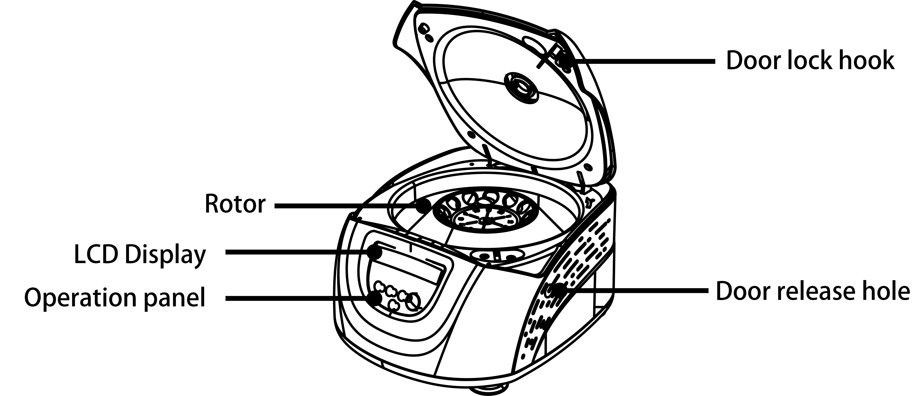6. Structure

Figure 6-1 Front view of the centrifuge
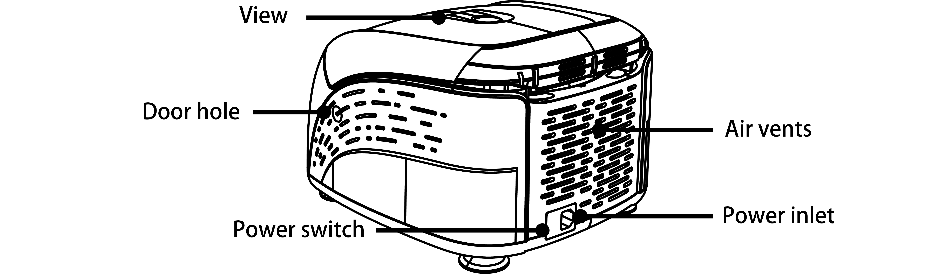

Figure 6-2 Rear view of the centrifuge

7. Operation panel
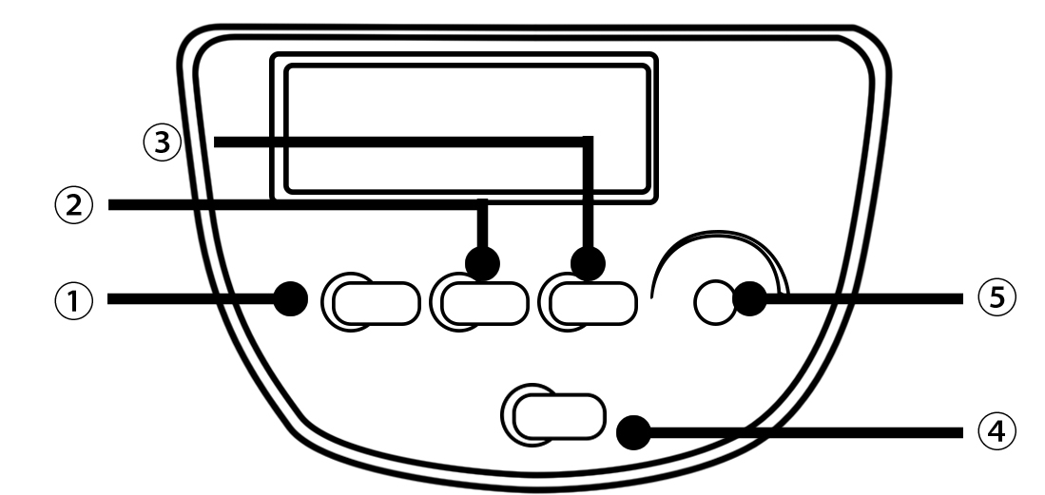

Figure 7-1 Operation panel

Item | Symbol | Name | Function
1 |  | Program button | Press the button to choose the programs
2 |  | Step button | Press for step choose and hold on 5s for RCF switch display
3 | 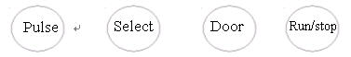 | Open/ lock button | Press the button to open the door The button is not available when the centrifuge is running.
4 |  | Start/ Stop button | Press the button to start running. The centrifuge will brake to stop running if pressed during centrifugation.
5 | 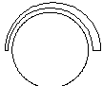 | Parameter button | Clockwise rotate to increase program values. Rotate anti-clockwise to decrease parameter values.  Press the button, shift between speed and RCF display.

Program Speed area Lock status Time area

Figure 7-2 The main interface
Main interface is as figure 7-2. The program is for PRP function. The speed is set to be 3480rpm, the door lock is released and the running time is 3 minutes. When speed symbol is rotating, this indicates the
centrifuge is running. If the rotation is faster, the speed is higher. Time symbol displays the time setting.

8. Rotor Preparation

8.1 Prepare the samples

8.2 Inject the samples into tubes
CAUTION
- Do not overload samples into the centrifuge which will cause leaking.
- Do not exceed the actual capacity allowed in the user manual.

8.3 Keep the tubes balanced
- Although the centrifuge can accept sample balancing by eye, we recommend that you keep this centrifuge in a well-balanced condition to extend its life expectancy.
- Never intentionally run the centrifuge under an unbalanced condition even though the allowable imbalance is not exceeded.

8.4 Inspect the rotor
Check the rotor for corrosion or scratches before using.
CAUTION
- If any abnormality such as corrosion or scratches are found, stop using the rotor and contact our service center.
- Only manufacturer’s rotors must be used with the unit.

8.5 Symmetrically load centrifuge tubes into rotor
CAUTION
- Make sure the rotor lid is securely fixed on the rotor, as well as the rotor and shaft are tightened. Otherwise, the rotor may be moved off while rotating and cause damage to the centrifuge and rotor.
- Firmly tighten the rotor lid to the rotor.

9. Operation
CAUTION
- Do not push or lean against the centrifuge while it is running.
- Do not run the centrifuge when fragments or sample solutions are left in the centrifuge chamber. Always keep the centrifugal chamber clean.
- If the centrifuge makes strange noise during operation, stop it immediately and contact our service center. Notify them of the warning code if displayed.

9.1 Normal operation
Turn on the power switch, centrifuge will display the running interface last time after passing the self-diagnostic checks.

9.1.1 Preloaded Programs Operation
1） PRP Program

（1）Press the button to select PRP program. Press buttonto start running.
- The door must be locked before rotor starts spinning.
- Timer will operate once the speed setting value is reached, the screen displays the remaining run time.
（2） View and modify the operation programs
- Press parameter knobfor 5 seconds, When flashing, rotate parameter knob to modify values. Release the button after 5 seconds, and the centrifuge will save the new value.
（3） Warning display
- If an error occurs during the operation, the centrifuge will brake to stop automatically, and display the error code on the time/display area. The error code can be checked in the table 11-1, and corrective actions can be applied accordingly.

2）PRF Program
（1）Press the button to select PRF program. Press buttonto start running.
- The door must be locked before rotor starts spinning.
- Timer will operate once the speed setting value is reached, the screen displays the remaining run time.
（2） View and modify the operation programs
- Press parameter knobfor 5 seconds, When flashing, rotate parameter knob to modify values. Release the button after 5 seconds, and the centrifuge will save the new value.
（3）Warning display
- If an error occurs during the operation, the centrifuge will brake to stop automatically, and display the error code on the time/display area. The error code can be checked in the table 11-1, and corrective actions can be applied accordingly.

3）CGF Program
（1）Press the button to select CGF program. Press button to start running.
- The door must be locked before rotor starts spinning.
- Timer will operate once the speed setting value is reached, the screen displays the remaining run time.
（2）View and modify the operation programs
● Press parameter knobfor 5 seconds, When flashing, rotate parameter knob to modify values. Release the button after 5 seconds, and the centrifuge will save the new value.
（3）Warning display
- If an error occurs during the operation, the centrifuge will brake to stop automatically, and display the error code on the time/display area. The error code can be checked in the table 11-1, and corrective actions can be applied accordingly.

4) End the operation
（1） The centrifuge will brake when it reaches the set time or button is pressed.
● When the rotor stops rotating, the centrifuge will start beeping to alert the operation has finished.
（2） Open the door
- The door can be released automatically when the operation has stopped.
- With the door closed, you are able to press the button to open it.
- After ending the operation, the program will store the setting parameters of this operation, and will recall these parameters when restarting the program.
（3） Open the door and take out the rotor and samples.

9.1.2 Customized program operation

Press the button to select P program. There are 9 programs (P1-P9) available and 6 steps for each program.
1）P1-P9 programs
（1） Press the button to select P1 program. When P1 icon flash, press parameter knobto confirm P1 program. Rotate the parameter knob to set the speed value and press to set time

value. Press step button to enter second step parameters setting. There are maximum 6 steps available for setting.
（2） Press button to start running.
（3） Warning display
- If an error occurs during the operation, the centrifuge will brake to stop automatically, and display the error code on the time/display area. The error code can be checked in the table 11-1, and corrective actions can be applied accordingly.

2）End the operation
（1） The centrifuge will brake when it reaches the set time or button is pressed.
- When the rotor stops rotating, the centrifuge will start beeping to alert the operation has finished.
（2） Open the door
- The door can be released automatically when the operation has stopped.
- With the door closed, you are able to press the button to open it.
- After ending the operation, the program will store the setting parameters of this operation, and will recall these parameters when restarting the program.
（3） Open the door and take out the rotor and samples.

9.2 RCF operation
（1） Turn on the power switch

- Set a RCF (Relative Centrifugal Force) value
CAUTION
- Do not exceed the allowable maximum RCF value of the rotor and adapters.

- Press the step button for 5 seconds and the speed symbol will flash into RCF value input status, press again for 5 seconds to return RPM value input mode.
- Rotate program knobto input a RCF value, RCF increment is10×g.

（3） Set operating conditions
The other operation, please refer to the section 8.1.

9.3 Reset

If you need reset the programs parameters, press the door button for 10 seconds;

10. Maintenance

10.1 Cleaning
CAUTION
- If do not follow the recommended instructions for cleaning or disinfecting this may damage the centrifuge.

（1）Centrifuge
- If the centrifuge is exposed to ultraviolet rays for a long time, the color of the door may be changed or the label may be peel off. After using, cover the centrifuge with a piece of cloth to protect it from direct exposure.
- If the centrifuge needs cleaning, clean it with a cloth or sponge moistened with a neutral detergent solution.
- Sterilize the centrifuge by wiping with a cloth moistened with 70% ethanol solution.
（2）Rotor chamber
CAUTION
- Do not directly pour water, neutral detergent or disinfectant solution into the rotor chamber, otherwise fluids may leak into the drive units and cause corrosion or deterioration to the bearings.

- If the rotor needs cleaning, clean with cloth or sponge moistened with a neutral detergent solution. Sterilize the centrifuge by wiping with a cloth moistened with 70% ethanol solution.
（3）Drive shaft
- We recommend regular maintenance for drive shaft. You can wipe the drive shaft with soft cloth, and then apply a thin coat of silicon grease.
（4）Door
- Clean and sterilize the door using the same method as the section（1）above.
（5）Rotor
- To prevent corrosion, remove the rotor from rotor chamber. If not in use for a long term, then detach the rotor lid and turn upside down to dry the tube holes and keep clean.
- For sample leaks in the rotor, rinse the rotor with water. Apply a thin coat of silicon grease to the rotor when it is completely dry.
- The rotor should be checked every 3 months to ensure the tube and rotor holes keep are clean and apply a thin coat of silicon grease.

10.2 Rotor Installation

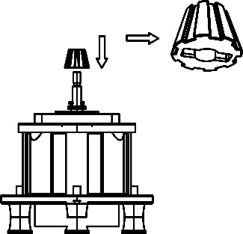
（1）Installation
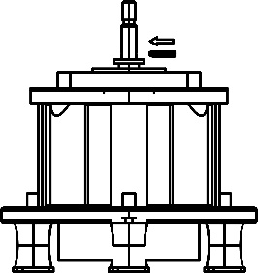

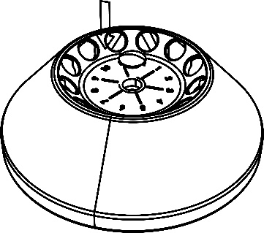
- ②
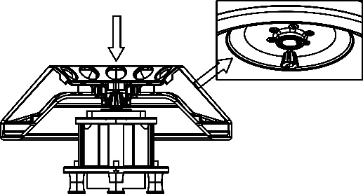

④

（2）Adjustment
Observe here!
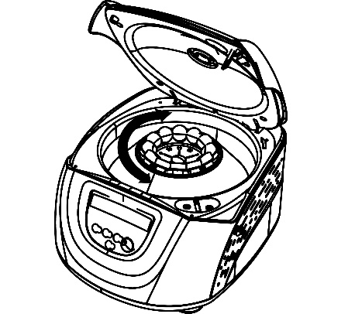
Before lock the rotor, rotate it, and observe carefully if there is obvious vibration, if so, please take off the rotor, turn some angle and install it again, until the rotor rotates smoothly, then, lock it firmly.

11. Troubleshooting

11.1 Possible problems and solutions
This centrifuge has a self-diagnostic function. If a problem occurs, an error/warning code will be displayed on the time display screen, and the operator can determine the malfunction with the alarm code below.
Symptom |  | Causes | Solutions
Nothing appears on the screen when the POWER is turned on. |  | ·Building power circuit breaker trips. | ·Remove the trouble and turn on the POWER.
Abnormal vibration |  | ·Rotor do not match with spindle  ·Samples are imbalance | ·Install again the rotor  ·Weighting scales, install symmetrically
Alarm code appeared on the time display screen | E-02  Door fault | ·The door opened in running.  ·The 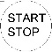button is pressed while the door opening. | ·Close the door immediately.  ·Close the door，and then start to operate.
Alarm code appeared on the time display screen | E-06  Set wrong speed | ·The setting speed exceed the allowable range. | ·Modify the speed value.
Alarm code appeared on the time display screen | E-10～86 | ·Read the service manual | ·Contact with service center
Table 11-1 Possible problems and solutions
- Alarm codes E-1～E-9 are related to incorrect operation/programming. You can continue running the centrifuge after implementing corrective procedures.

11.2 How to open the door
1) In the case of power on
CAUTION
- The door just can be opened while the power is on and rotor stops rotating.

（1） Turn on the power switch, release the door automatically.
（2） The door will be released automatically once the operation is finished.
（3） It is available to release the door by press button once the rotor stops.
2) In the case of power outage
The door cannot be opened automatically if there is a power outage. It is available to be opened manually as follows.
（1）Ensure if the rotor has stopped rotating.
- Listen carefully to ensure no rotating sound can be heard.
（2）Insert a screw driver into a hole to open door.
- Holes are located on the left and right sides of the unit.
- Insert a screw driver into the two holes and push forward to release the door.

12. Instructions for the rotor and tubes
CAUTION
- Read the instructions thoroughly, to properly load and use rotor.
- Do not exceed the allowable maximum speed of rotor、tube and adapters etc. Ensure the allowable maximum speed of adapters is lower than the rotor’s maximum speed.

12.1 Rotor instructions
1) Rotor structure

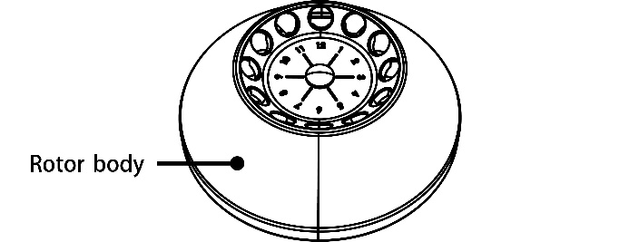

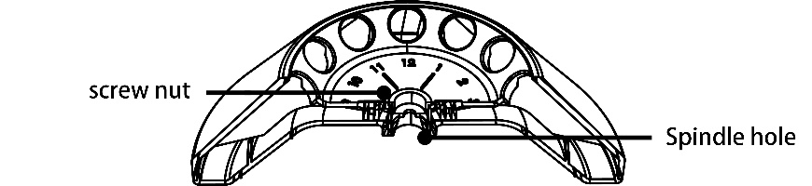

Figure 12-1 The rotor structure
- Available rotors and adapters
Rotor type | Tubes | Tubes  Per Rotor | Dimension  (Ф×L mm) | Adapters | Maximum speed（rpm） | Radius  cm | Maximum RCF  (×g）
A12-10P | 15ml con | 8 | 17×120 |  | 4500 | 11 | 2490
A12-10P | 1.5-5ml vacu | 12 | 13×82 | A10P15  mat | 4500 | 9.8 | 2218
A12-10P | 4-7 ml vacu | 12 | 13×106 | A10P15 | 4500 | 11 | 2490
A12-10P | 4-7 ml vacu | 12 | 16×75 | A10P15  Mat | 4500 | 9.8 | 2218
A12-10P | 8.5-10 ml vacu | 12 | 16×107 | A10P15 | 4500 | 11 | 2490
A12-10P | 2.7-3  (EU) ml collection tube | 12 | 11×66 | A10P15  mat | 4500 | 9.8 | 2218
A12-10P | 7.5-8.2  (EU)ml collection tube | 12 | 15×92 | A10P15 | 4500 | 11 | 2490
Table 12-1 Rotors and adapters
- Notice
- The centrifuge rotor can separate samples with a density lower than 2.0g/ml. If the samples density is over 2.0g/ml, please calculate allowable speed depending on the following formula.
- Autoclaving
A12-10P rotor is made of plastic, cannot be high-pressure sterilization and UV irradiation, only ordinary sterilization can be used.

12.2 Tubes
1) Cleaning and sterilizing tubes
O：Applicable X：Inapplicable
Conditions Materials |  |  | PA | PC | PP
Cleaning | Cleaning fluids | Acidic（pH5 or lower） | X | X | X
Cleaning | Cleaning fluids | Acidic（higher than pH5 ） | O | O | O
Cleaning | Cleaning fluids | Alkaline（higher than pH9 ） | O | X | O
Cleaning | Cleaning fluids | Alkaline（pH9 or lower） | O | O | O
Cleaning | Cleaning fluids | Neutral（pH7） | O | O | O
Cleaning | Cleaning fluids | Warm water(up to 70℃) | O | O | O
Cleaning | Ultrasonic cleaning | Neutral detergent（pH7） | O | O | O
Sterilization | Autoclaving | 115℃（0.7kg/cm²）30minutes | O | O | O
Sterilization | Autoclaving | 121℃（1.0kg/cm²）20 minutes | X | O | O
Sterilization | Autoclaving | 126℃（1.4kg/cm²）15 minutes | X | X | X
Sterilization | Boiling | 15 to 30 minutes | O | O | O
Sterilization | Ultraviolet sterilization | 200-300nm | X | X | X
Sterilization | Gas sterilization | Ethylene oxide | O | X | O
Sterilization | Gas sterilization | Formaldehyde | O | O | O
PA: Polyallomer PC: Polycarbonate PP: Polypropylene
Table 12-2 Cleaning and sterilizing conditions for tubes
- Cleaning PC tubes
PC material is low in chemical resistance against alkaline solutions. Avoid using neutral detergents with pH higher than 9. Note that pH of some neutral detergents are still higher than 9 even if diluted according to the manufacturer’s instructions. Use detergent with its pH between 7 and 9.
- Autoclaving PA、PC and PP tubes
PA begins softening at about 120℃, PC and PP at about 130℃. Autoclave PA tubes at 115℃（0.7kg/cm²）for 30 minutes, PC and PP tubes at 121℃（0.1kg/cm²）for 20 minutes. If a certain temperature is exceeded, the tubes may be deformed.
When use a sterilizing chamber, please operate as follows:
(1) Place tubes in vertical position, mouths upward. If tubes are placed sideways, they may deform into an oval shape due to gravity.
(2) Remove locking nut and lid to prevent from deformation or rupture.
(3) Wait until the sterilizing chamber cools down to the room temperature before removing tubes.
4) Conditions and life expectancy of tubes
The life expectancy of plastic tubes depends on the characteristics of samples, speed of the rotor used, temperature applied and so on. When the plastic tubes are used for ordinary aqueous samples (pH between 5.0 and 9.0), their life expectancies are defined as follows.
Be operated at the maximum speed:
High quality tubes (PA、PC、PP): 30-50 operations
Ordinary tubes(PA、PC、PP): around 10 operations（Using in low speed can extend the tube life）.
Life expectancy of tubes also depends on the pretreatment conditions such as cleaning and sterilization, lifetime can be cut down.
Notice: Do not use damaged or cracked tubes.

13. Calculate RCF
An RCF can be determined with the following calculation formula.
RCF=1.118×r×n²×10⁻⁵
r—rotating radius, unit: cm; n—rotating speed, unit: rpm

14. Returning and Disposal

14.1 Returning Devices
Before returning the device, a transport securing device has to be installed.
If the device or its accessories are returned back, in order to provide protection for people, the environment and materials, it has to be decontaminated and cleaned before being shipped.

14.2 Disposal
Before disposal, the device must be decontaminated and cleaned to protect people, the environment and property. When you are disposing of the device, the respective statutory rules must be observed.
Pursuant to guideline 2002/96/EC (WEEE), all devices supplied after August 13,2005 may not be disposed as part of domestic waste. The device belongs to group 8 (medical devices) and is categorized in the business-to-business field.
The icon of the crossed-out trash can shows that the device may not be disposed as part of domestic waste. The device belongs to group 8 (medical devices) and is categorized in the business-to-business field.
The waste disposal guidelines of the individual EC countries might vary. If necessary, contact your supplier.

15．Warranty

15.1 Warranty of centrifuge
This centrifuge is guaranteed for one years from the date of delivery provided that it has been operated and maintained properly.

15.2 Warranty of the rotor
The rotor is guaranteed for 5 years from the date of delivery upon manufacturer. Please pay attention, do not use the rotor once it has been corrosion or fatigue damage. The warranties of the centrifuge and the rotor become invalid in the case of the following conditions even if within the guarantee period expires:
- Failures caused by incorrect installation.
- Failures caused by rough or improper handling.
- Failures caused by conveyance or relocation after installation.
- Failures caused by unauthorized disassembly or modification.
- Failures caused by using non-standard spare parts or accessories and unauthorized modification of the rotor or centrifuge.
- Failures caused by natural disasters including fire, earthquakes and so on.
- Consumables and parts have a limited guarantee period.

After-sales service
In order to ensure to operate centrifuge safely and efficiently, it is necessary for regular maintenance. If centrifuge has problems, do not attempt to repair it by yourself. Contact our sales or service center.

CONTACT US


DLAB Scientific Co., Ltd
Yu An Road 31, Beijing Airport Economic core zone,
Shun yi District, Beijing, China 101318
Tel: 86-10- 85653451/52/53
Fax: 86-10-85653383
E- mail: info@dlabsci.com
web: www.dlabsci.com

